**Project Report**

**ABSTRACT: -**

Exam software is a test management software, which offers a complete solution for Computer Based Test (CBT). They are used to set up multiple choice tests for set time that when and submitted are automatically corrected and the result logged.

**WHAT IMPACT DOES IT HAVE: -**

Physical presence at a given location is absolutely not necessary. No time is spent on evaluation. Result are available instantly.

PURPOSE: - The main objective of this test is to efficiently evaluate the candidate thoroughly through a fully automated system that not only saves a lot of time but also give fast result.

**FEATURES : -**

1. Secure.
2. Easy to use
3. Reliable and Accurate
4. no need of examine

In this project, there are given 10 questions to play. User can bookmark any question for the reconsideration while going to result.

We are using here java array to store the questions, options and answers not database. You can use collection framework or database in place of array.

**INTRODUCTION: -**

The **Online Quiz is a web application** for candidate to appear for an online test in an effective way and there is no loss of time to check the paper. The chief aim of Online Quiz is to effectively estimate the candidate completely via a totally automated system which besides preserving time, offers swifter outcomes. Generally, pupil are provided with paper, pen etc for taking the test but the Online Quiz doesn’t require all these.

This application is fundamentally developed in WordPress, which is a web software that can be employed to develop a wonderful website or a blog. The advantage of this software is that it is free as well as costless.

**Scope: -**

This project has a wide scope as it is better than the manual tests. Following are some of its advantages:

* Both educational organizations and corporate companies can employ this Quiz.
* It, being an application based on web may be taken at any place or any time as the location is not considered.
* The presence of the examiner is not required while the candidate is appearing for the test.

**Benefits: -**

For web surfers, Online Quiz acts as a popular way of recreation. It is free of cost and meant for entertainment and they also give prizes. Online Quiz is organized to examine the wisdom or identify a person’s characteristics. Most of the companies employ online quiz as an effective manner of examining a prospective employee’s wisdom without that person’s personal presence.

**Screenshots: -**

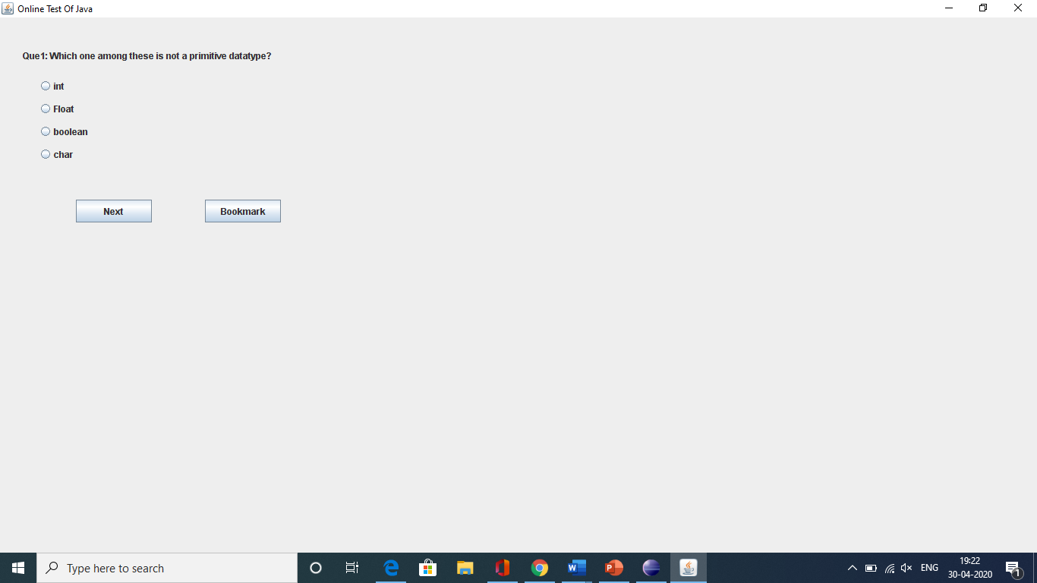

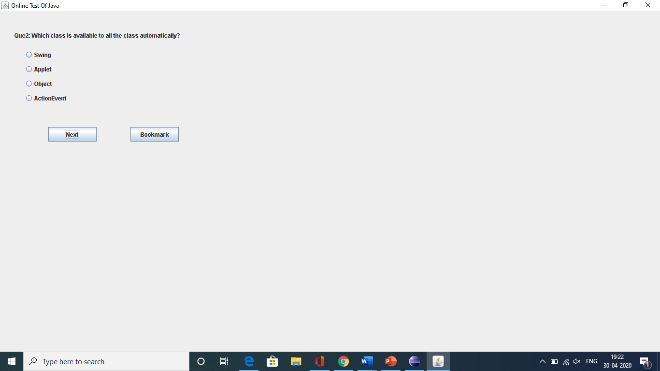

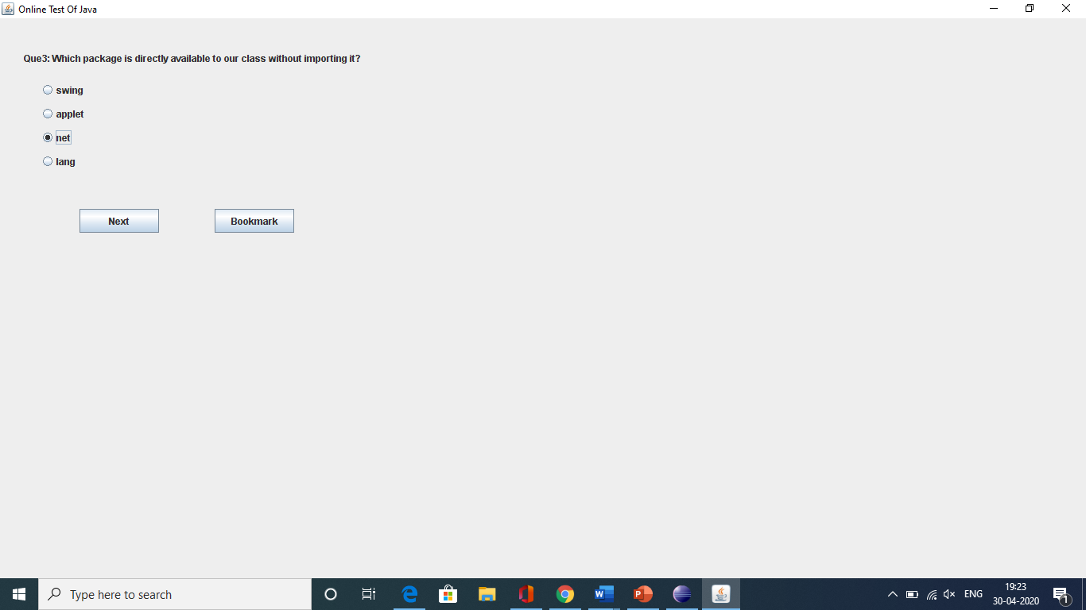



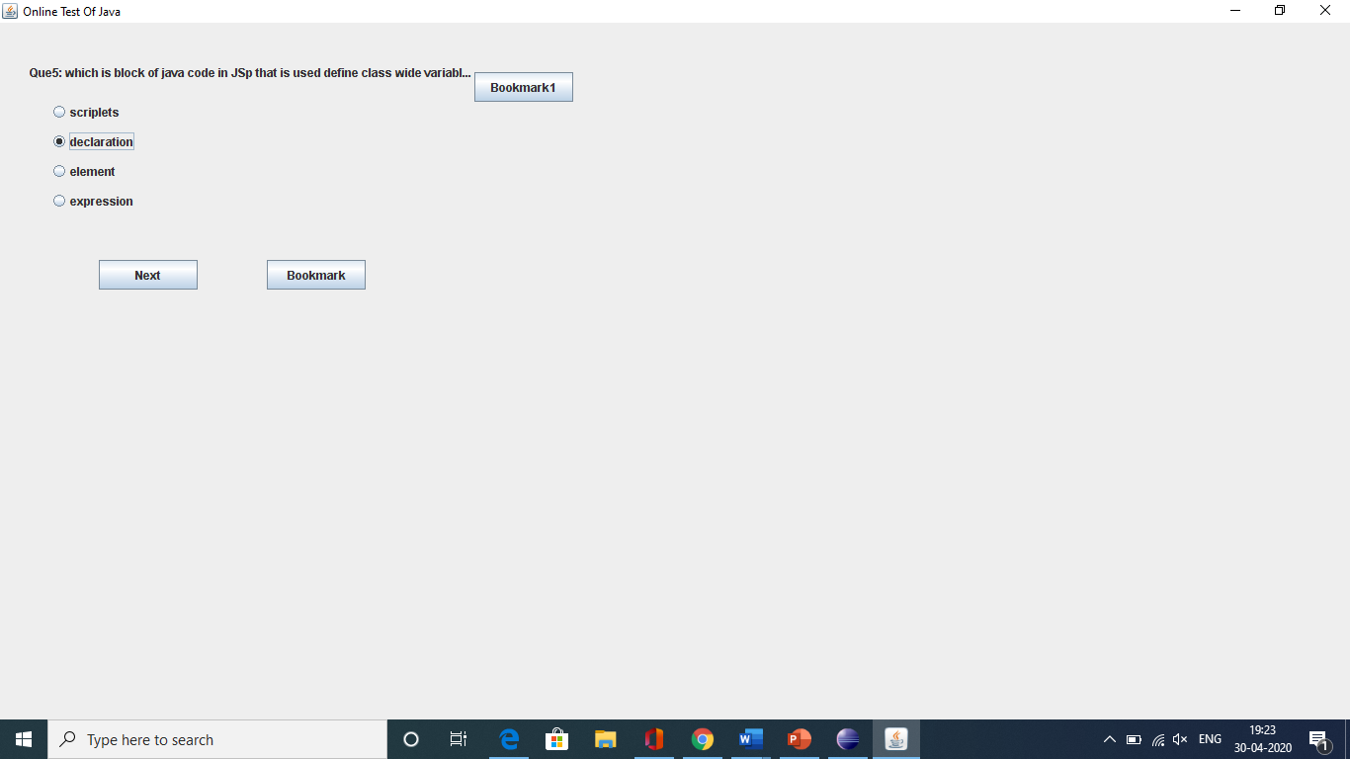

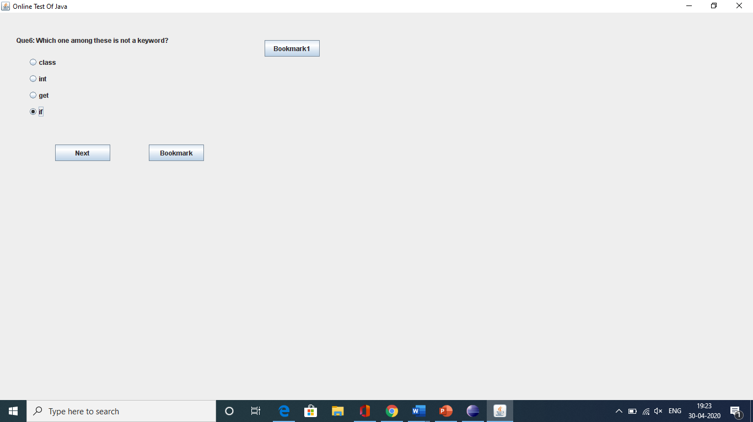

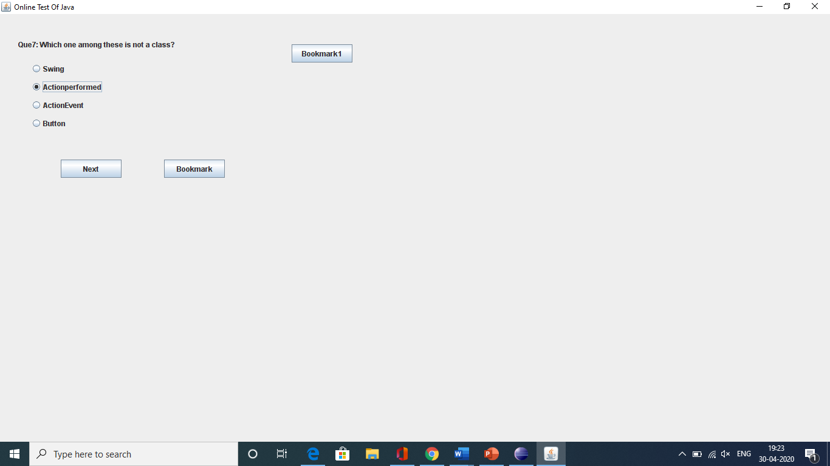

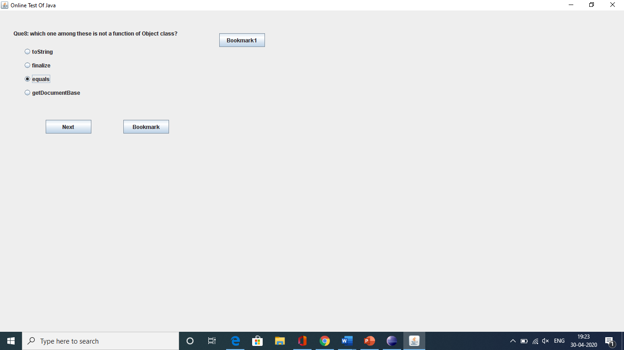

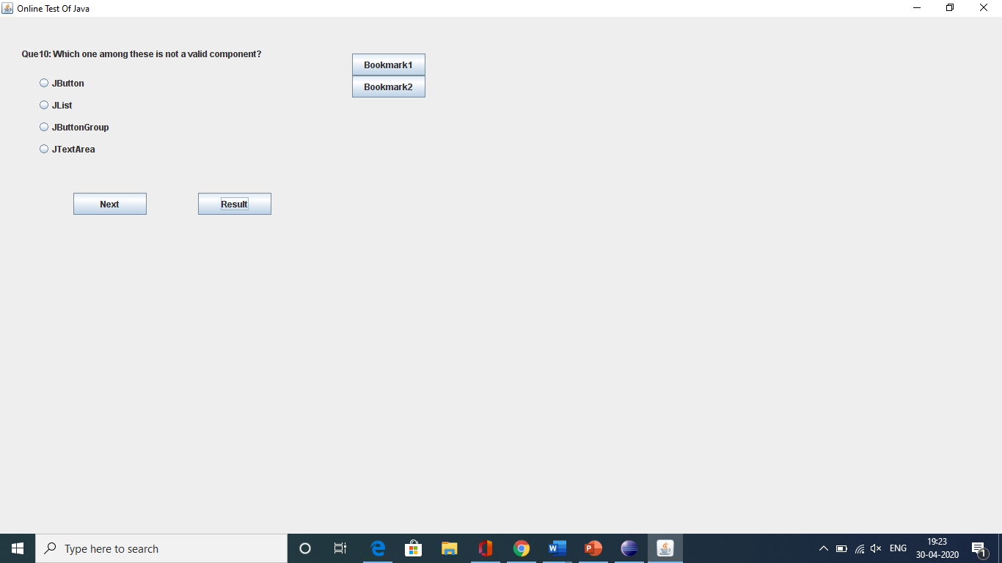

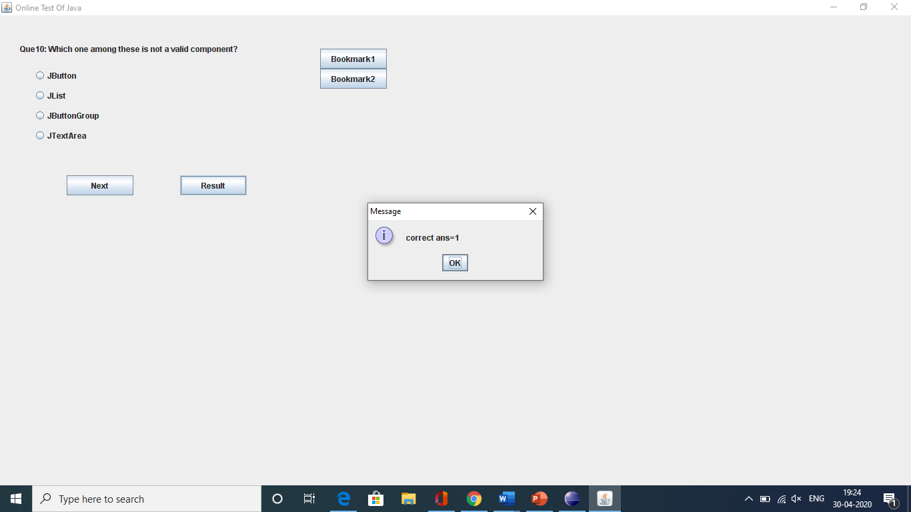

Submitted To: - Mr. Sachin Chirgaiya

Submitted By: - Sara Nahar

Class: -CS – I (B.Tech+M.B.A)